|  |
| --- |
| **Prechecks & Postchecks Scripts** |
| ip a;df -hTP;blkid;vxdisk list; vxdisk listtag; vxprint; ip a; hastatus -sum; vxdg list;haclus -list; hasys -list; vxdctl -c mode; vradmin printrvg(this is for 4 node cluster) |

**For Cluster servers Migration SOP:--**

**Must take screenshots for all cluster servers—**

**For e.g-**

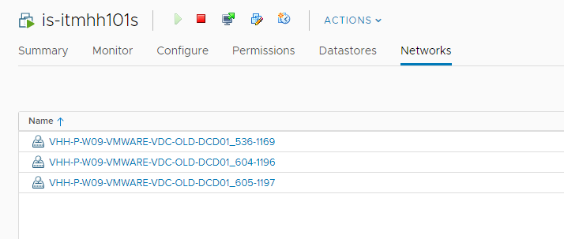

**To check which one is master node—**

vxdctl -c mode

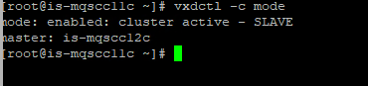

**For any of the Cluster server we must have to check for hastatus -sum—**

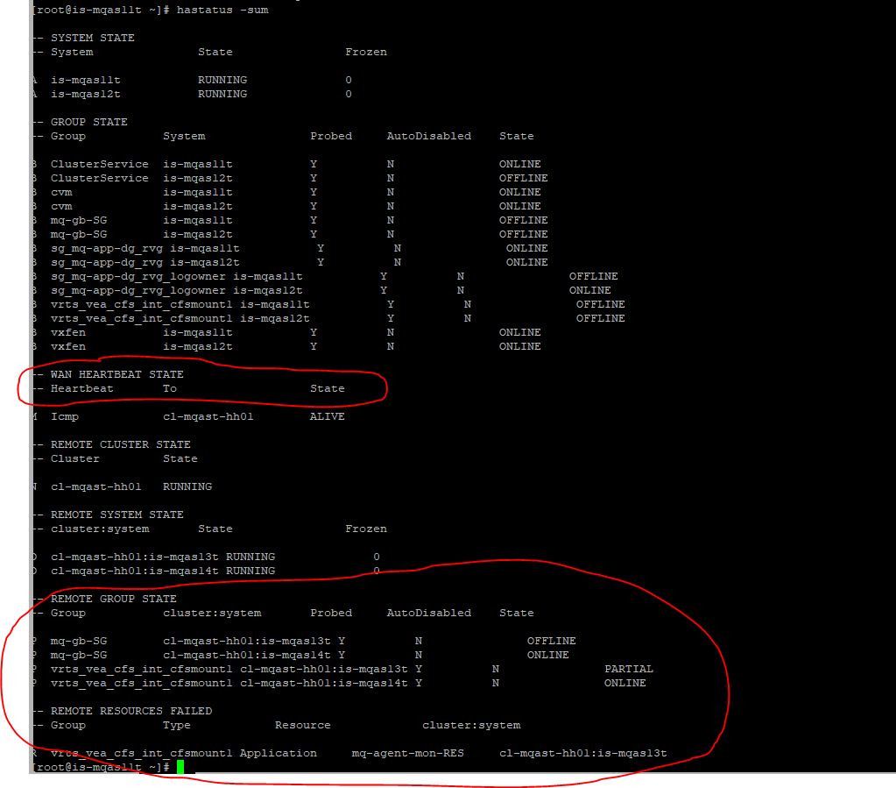

--🡪 In every cluster We have to check for is server is two node or 4 node by checking above parameters in red circle.

* **Heartbeat ip always exist in Global Clusters only.**
* **CB or OE are the same things in case of Clusters like VHH and VOE(CB-old naming convention)**

**OE- New naming Convention**

**Below two command for backup of VCS clusters (have to run on any one server)--**

# cd /opt/VRTSspt/VRTSexplorer   
# ./VRTSexplorer (Check all the Relevant options than only enter/y/n)

1.For main.cf backup—

**cd /etc/VRTSvcs/conf/config --(on any of the Cluster server)**

**cp -p main.cf /var/tmp/main.cf.28thNov**

**e.g—**

**8 2022/11/28 13:30:20 :: chmod 777 main.cf.28thNov-is-mqscc11c**

**9 2022/11/28 13:30:37 :: ls -ltr main.cf.28thNov-is-mqscc11c**

**10 2022/11/28 13:31:04 :: chown g83890-udm:users main.cf.28thNov-is-mqscc11c**

* **Change new ip and gateway for host ip.**

hastop -- for stop cluster services(on master server)

hastatus -sum ---for check the status of cluster services.

this o/p must be comes like—

VCS ERROR V-16-1-10600 Cannot connect to VCS engine

VCS WARNING V-16-1-11046 Local system not available

**Run hastop on both of servers.**

* **Then Give to Windows team for Cutover**…

After cutover Completion of servers change the Ips{and one gateway also change from old to new Gateway IP} in **/etc/VRTSvcs/conf/config**  for both of the host and clusters ip on all cluster servers—

* Then hastart on both servers.

We can take reboot of master server too if “hastatus -sum” o/p not matched with cluster o/p

Match the hastatus -sum on both of servers with cluster o/p

**Clusterservice** & **mq-gb-SG** may be running on any node no issue but must be online at one server.

The **Clusterservice** service online on whichever server that is become master node then…

To clear and Set the desired service—

** watch hastatus -sum -- for refresh the hastatus o/p.

60MQ- 2node cluster servers Migration—

Prechecks for 60MQ—

df -hPT > /tmp/precheck.txt  
df -h|wc -l >> /tmp/precheck.txt  
df -h >> /tmp/precheck.txt  
cat /etc/fstab >> /tmp/precheck.txt  
blkid >> /tmp/precheck.txt  
lsblk >> /tmp/precheck.txt  
vxdisk list >> /tmp/precheck.txt  
vxprint >> /tmp/precheck.txt  
ip a >> /tmp/precheck.txt  
vxdg list >> /tmp/precheck.txt  
hastatus -sum >> /tmp/precheck.txt  
hagrp -state >> /tmp/precheck.txt  
hares -state >> /tmp/precheck.txt  
hasys -list >> /tmp/precheck.txt  
haclus -list >> /tmp/precheck.txt  
dspmq -x >> /tmp/precheck.txt  
cat /etc/resolv.conf >> /tmp/precheck.txt  
adinfo >> /tmp/precheck.txt  
cat /etc/exports >> /tmp/precheck.txt  
uname -a >> /tmp/precheck.txt  
cat /etc/redhat-release >> /tmp/precheck.txt  
rpm -qa --last | grep kernel >> /tmp/precheck.txt  
rpm -qa --last | grep vx >> /tmp/precheck.txt  
/opt/nordea/healthcheck/scripts/veritas.sh >> /tmp/precheck.txt

=======================================================================================

[root@is-mqis11t ~]# history  
    1  2023/01/20 07:56:32 :: ifconfig -a  
    2  2023/01/20 07:57:31 :: nslookup 10.53.99.163  
    3  2023/01/20 07:58:10 :: nslookup 10.158.104.217  
    4  2023/01/20 07:58:33 :: nslookup 10.158.104.217  
    5  2023/01/20 12:13:48 :: ifconfig  
    6  2023/01/20 12:14:48 :: nslookup 10.158.104.217  
    7  2023/01/20 12:30:18 :: ping 10.158.104.217  
    8  2023/01/20 12:31:17 :: nslookup 10.158.104.217  
    9  2023/01/20 12:31:50 :: hastatus -sum  
   10  2023/01/20 12:33:10 :: nslookup 10.53.99.163  
   11  2023/01/20 12:33:38 :: cd /etc/sysconfig/network-scripts/  
   12  2023/01/20 12:33:45 :: ls -ltr  
   13  2023/01/20 12:33:50 :: ls  
   14  2023/01/20 12:34:26 :: ifconfig -a  
   15  2023/01/20 12:35:34 :: cat ifcfg-eth1  
   16  2023/01/20 12:36:51 :: cd  
   17  2023/02/28 10:11:56 :: cat /etc/redhat-release;uname -a;cat /etc/resolv.conf;cat /etc/hosts;rpm -qa --last | grep kernel;rpm -qa | grep vx;df -hPT;df -h | wc -l;cat /etc/fstab;blkid;lsblk;vxdisk list;vxdisk listtag;vxprint;ip a;hastatus -summ;vxdg list;haclus -list;hasys -list  
   18  2023/02/28 10:51:32 :: hastatus -sum  
   19  2023/02/28 12:07:21 :: dspmq -x  
   20  2023/02/28 12:11:51 :: hagrp -offline vrts_vea_cfs_int_cfsmount1 -sys is-mqis11t  
   21  2023/02/28 12:12:15 :: hastatus -sum  
   22  2023/02/28 12:12:46 :: hastatus -sum  
   23  2023/02/28 12:13:34 :: watch hastatus -sum  
   24  2023/02/28 12:13:59 :: dspmq -x  
   25  2023/02/28 12:22:35 :: vim /etc/sysconfig/network-scripts/ifcfg-eth0  
   26  2023/02/28 12:23:11 :: vim /etc/sysconfig/network  
   27  2023/02/28 12:23:34 :: cat /etc/sysconfig/network-scripts/ifcfg-eth0  
   28  2023/02/28 12:23:48 :: history

**For VVR Replication Configuration Steps Forwarded by Deepak Bhatia & Sachin Sir--**

Run this on both sites

DG=uc4stdb-dg  
IP_PRIMARY=10.96.141.87 <--- your new IP for the primary site  
IP_SECONDARY=10.96.141.84 <--- your new IP for the secondary site  
RLINK_LOCAL=$(vxprint -g ${DG} -Pl|awk '$1 == "Rlink:" {print $2}')  
echo -e "DG: $DG\nRLINK_LOCAL: $RLINK_LOCAL\nIP_PRIMARY: $IP_PRIMARY\nIP_SECONDARY: $IP_SECONDARY"

Before you start ensure data are up to date, run on primary

vxrlink -g ${DG} -i 1 status ${RLINK_LOCAL}

On primary and secondary site, start with primary

vxrlink -g ${DG} pause ${RLINK_LOCAL}  
On primary site

vxedit -g ${DG} set local_host=${IP_PRIMARY} ${RLINK_LOCAL}  
vxedit -g ${DG} set remote_host=${IP_SECONDARY} ${RLINK_LOCAL}  
On Secondary site

vxedit -g ${DG} set local_host=${IP_SECONDARY} ${RLINK_LOCAL}  
vxedit -g ${DG} set remote_host=${IP_PRIMARY} ${RLINK_LOCAL}  
On primary and secondary site, start with primary

vxrlink -g ${DG} resume ${RLINK_LOCAL}  
You may have to change the RVG IP resource on both sites as well

hares -value ${DG}_rvg_IP Address

Primary & Secondary Ip Syncing issue(Must Check in 4 Node Cluster)---

[Yesterday 5:56 PM] Chaudhary, Sachin – **Primary node**

[root@is-mqas14t ~]# history  
    1  2022/12/20 08:57:37 :: clear  
    2  2022/12/20 08:57:39 :: hastatus -sum  
    3  2023/03/20 17:43:04 :: vxdisk list  
    4  2023/03/20 17:43:51 :: hastatus -sum  
    5  2023/03/20 17:45:00 :: vxdctl -c mode  
    6  2023/03/20 17:45:05 :: vxdisk list  
    7  2023/03/20 17:47:15 :: DG=mq-app-dg  
    8  2023/03/20 17:47:15 :: IP_PRIMARY=10.97.80.150  
    9  2023/03/20 17:47:16 :: IP_SECONDARY=10.97.80.169  
   10  2023/03/20 17:47:21 :: nslookup 10.97.80.150  
   11  2023/03/20 17:47:24 :: ping 10.97.80.150  
   12  2023/03/20 17:47:30 :: ping 10.97.80.169  
   13  2023/03/20 17:47:35 :: nslookup 10.97.80.169  
   14  2023/03/20 17:47:51 :: ip a  
   15  2023/03/20 17:48:19 :: cat /etc/VRTSvcs/conf/config/main.cf | grep -i 10.97.80.150  
   16  2023/03/20 17:48:36 :: vxprint -ht | grep ^rl  
   17  2023/03/20 17:49:01 :: RLINK_LOCAL=$(vxprint -g ${DG} -Pl|awk '$1 == "Rlink:" {print $2}')  
   18  2023/03/20 17:49:13 :: echo -e "DG: $DG\nRLINK_LOCAL: $RLINK_LOCAL\nIP_PRIMARY: $IP_PRIMARY\nIP_SECONDARY: $IP_SECONDARY"  
   19  2023/03/20 17:50:32 :: vxrlink -g ${DG} -i 1 status ${RLINK_LOCAL}  
   20  2023/03/20 17:50:53 :: vxrlink -g ${DG} -l repstatus ${RLINK_LOCAL}  
   21  2023/03/20 17:51:09 :: vradmin -g ${DG} -l repstatus ${DG}_rvg  
   22  2023/03/20 17:51:38 :: vxedit -g ${DG} set local_host=${IP_PRIMARY} ${RLINK_LOCAL}  
   23  2023/03/20 17:51:48 :: vxedit -g ${DG} set remote_host=${IP_SECONDARY} ${RLINK_LOCAL}  
   24  2023/03/20 17:51:57 :: vxprint -ht | grep ^rl  
   25  2023/03/20 17:54:38 :: vradmin -g ${DG} -l repstatus ${DG}_rvg  
   26  2023/03/20 17:55:29 :: #vradmin -g ${DG} -a startrep ${DG}_rvg  
   27  2023/03/20 17:55:32 :: hastatus -sum  
   28  2023/03/20 17:55:47 :: vradmin -g ${DG} -a startrep ${DG}_rvg  
   29  2023/03/20 17:56:15 :: vradmin -g ${DG} -l repstatus ${DG}_rvg  
   30  2023/03/20 17:56:20 :: vradmin -g ${DG} -l repstatus ${DG}_rvg  
   31  2023/03/20 17:56:26 :: vradmin -g ${DG} -l repstatus ${DG}_rvg  
   32  2023/03/20 17:56:30 :: history  
[root@is-mqas14t ~]#

[Yesterday 5:57 PM] Chaudhary, Sachin --**Secondary node**

[root@is-mqas11t ~]# history  
    1  2022/12/01 12:20:44 :: hastatus -sum  
    2  2022/12/01 12:21:34 :: hastatus -sum | grep is-mqas11t | grep vrts_vea_cfs_int_cfsmount1  
    3  2022/12/01 12:21:51 :: hastatus -sum | grep is-mqas11t | grep vrts_vea_cfs_int_cfsmount1 | awk '{print $6}'  
    4  2022/12/01 12:21:57 :: which hastatus  
    5  2023/03/20 17:44:43 :: vxdctl -c mode  
    6  2023/03/20 17:44:50 :: hastatus -sum  
    7  2023/03/20 17:44:53 :: vxdisk list  
    8  2023/03/20 17:48:46 :: vxprint -ht | grep ^rl  
    9  2023/03/20 17:52:27 :: DG=mq-app-dg  
   10  2023/03/20 17:52:27 :: IP_PRIMARY=10.97.80.150  
   11  2023/03/20 17:52:27 :: IP_SECONDARY=10.97.80.169  
   12  2023/03/20 17:52:29 :: RLINK_LOCAL=$(vxprint -g ${DG} -Pl|awk '$1 == "Rlink:" {print $2}')  
   13  2023/03/20 17:52:43 :: echo -e "DG: $DG\nRLINK_LOCAL: $RLINK_LOCAL\nIP_PRIMARY: $IP_PRIMARY\nIP_SECONDARY: $IP_SECONDARY"  
   14  2023/03/20 17:53:00 :: vxrlink -g ${DG} -i 1 status ${RLINK_LOCAL}  
   15  2023/03/20 17:53:10 :: vxrlink -g ${DG} pause ${RLINK_LOCAL}  
   16  2023/03/20 17:53:26 :: vradmin -g ${DG} -l repstatus ${DG}_rvg  
   17  2023/03/20 17:53:38 :: vxprint -ht | grep ^rl  
   18  2023/03/20 17:53:54 :: vxedit -g ${DG} set local_host=${IP_SECONDARY} ${RLINK_LOCAL}  
   19  2023/03/20 17:54:03 :: vxedit -g ${DG} set remote_host=${IP_PRIMARY} ${RLINK_LOCAL}  
   20  2023/03/20 17:54:12 ::  vxprint -ht | grep ^rl  
   21  2023/03/20 17:56:08 :: vxrlink -g ${DG} resume ${RLINK_LOCAL}  
   22  2023/03/20 17:57:04 :: history  
[root@is-mqas11t ~]#

If cluster o/p /// fencing not came up then run below—

[root@is-exasch2d ~]# cat /etc/vxfenmode  
vxfen_mode=customized  
vxfen_mechanism=cps  
cps1=[10.96.125.31]:443  
cps2=[10.96.140.32]:443  
cps3=[10.84.8.34]:443  
loser_exit_delay=55  
vxfen_script_timeout=25    ------>600   
[root@is-exasch2d ~]# vi /etc/vxfenmode  
[root@is-exasch2d ~]#  
[root@is-exasch2d ~]#  
[root@is-exasch2d ~]# systemctl restart vxfen.service